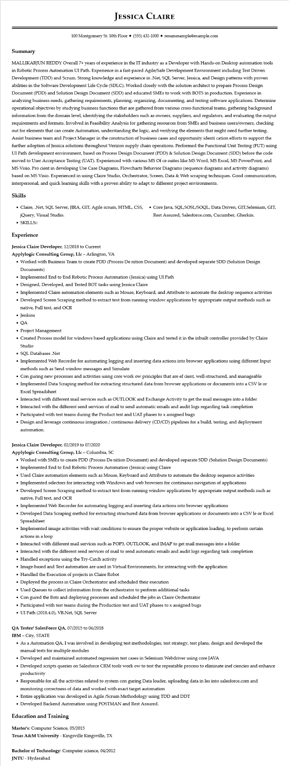
JESSICA CLAIRE
100 Montgomery St. 10th Floor⚫ (555) 432-1000⚫ resumesample@example.com
Summary
MALLIKARJUN REDDY Overall 7+ years of experience in the IT industry as a Developer with Hands-on Desktop automation tools in Robotic Process Automation UI Path. Experience in a fast-paced Agile/Safe Development Environment including Test Driven Development (TDD) and Scrum. Strong knowledge and experience in .Net, SQL Server, Jessica, and Design patterns with proven abilities in the Software Development Life Cycle (SDLC). Worked closely with the solution architect to prepare Process Design Document (PDD) and Solution Design Document (SDD) and educated SMEs to work with BOTS in production. Experience in analyzing business needs, gathering requirements, planning, organizing, documenting, and testing software applications. Determine operational objectives by studying business functions that are gathered from various cross-functional teams, gathering background information from the domain level, identifying the stakeholders such as owners, suppliers, and regulators, and evaluating the output requirements and formats. Involved in Feasibility Analysis for gathering resources from SMEs and business users/owners, checking out for elements that can create Automation, understanding the logic, and verifying the elements that might need further testing. Assist business team and Project Manager in the construction of business cases and opportunity identi cation efforts to support the further adoption of Jessica solutions throughout Verizon supply chain operations. Performed the Functional Unit Testing (FUT) using UI Path development environment, based on Process Design Document (PDD) & Solution Design Document (SDD) before the code moved to User Acceptance Testing (UAT). Experienced with various MS Of ce suites like MS Word, MS Excel, MS PowerPoint, and MS Visio. Pro cient in developing Use Case Diagrams, Flowcharts Behavior Diagrams (sequence diagrams and activity diagrams) based on MS Visio. Experienced in using Claire Studio, Orchestrator, Screen, Data & Web scraping techniques. Good communication, interpersonal, and quick learning skills with a proven ability to adapt to different project environments.
Skills
• Claire, .Net, SQL Server, JIRA, GIT, Agile scrum, HTML, CSS, jQuery, Visual Studio.
• SKILLS::
Experience
Jessica Claire Developer, 12/2018 to Current
Applylogic Consulting Group, Llc - Arlington, VA
• Core Java, SQL,SOSL/SOQL, Data Driven, GIT,Selenium, GIT, Rest Assured, Salesforce.com, Cucumber, Gherkin.
• Worked with Business Team to create PDD (Process De nition Document) and developed separate SDD (Solution Design Documents)
• Implemented End to End Robotic Process Automation (Jessica) using UI Path
• Designed, Developed, and Tested BOT tasks using Jessica Claire
• Implemented Claire automation elements such as Mouse, Keyboard, and Attribute to automate the desktop sequence activities
• Developed Screen Scraping method to extract text from running window applications by appropriate output methods such as native, Full text, and OCR
• Jenkins
• QA
• Project Management
• Created Process model for windows based applications using Claire and tested it in the inbuilt controller provided by Claire Studio
• SQL Databases .Net
• Implemented Web Recorder for automating logging and inserting data actions into browser applications using different Input methods such as Send window messages and Simulate
• Con guring new processes and activities using core work ow principles that are ef cient, well-structured, and manageable
• Implemented Data Scraping method for extracting structured data from browser applications or documents into a CSV le or Excel Spreadsheet
• Interacted with different mail services such as OUTLOOK and Exchange Activity to get the mail messages into a folder
• Interacted with the different send services of mail to send automatic emails and audit logs regarding task completion
• Participated with test teams during the Product test and UAT phases to x assigned bugs
• Design and leverage continuous integration/continuous delivery (CD/CD) pipelines for a build, testing, and deployment automation.
Jessica Claire Developer, 02/2019 to 07/2020
Applylogic Consulting Group, Llc - Columbia, SC
• Worked with SMEs to create PDD (Process De nition Document) and developed separate SDD (Solution Design Documents)
• Implemented End to End Robotic Process Automation (Jessica) using Claire
• Used Claire automation elements such as Mouse, Keyboard and Attribute to automate the desktop sequence activities
• Implemented selectors for interacting with Windows and web browsers for continuous navigation of applications
• Developed Screen Scraping method to extract text from running window applications by appropriate output methods such as native, Full text, and OCR
• Implemented Web Recorder for automating logging and inserting data actions into browser applications
• Developed Data Scraping method for extracting structured data from browser applications or documents into a CSV le or Excel Spreadsheet
• Implemented image activities with wait conditions to ensure the proper website or application loading, to perform certain actions in a loop
• Interacted with different mail services such as POP3, OUTLOOK, and IMAP to get mail messages into a folder
• Interacted with the different send services of mail to send automatic emails and audit logs regarding task completion
• Handled exceptions using the Try-Catch activity
• Image-based and Text automation are used in Virtual Environments, for interacting with the application
• Handled the Execution of projects in Claire Robot
• Deployed the process in Claire Orchestrator and scheduled their execution
• Used Queues to collect information from the orchestrator to perform additional tasks
• Con gured the Bots and deploying processes and scheduled the jobs in Claire Orchestrator
• Participated with test teams during the Production test and UAT phases to x assigned bugs
• UI Path (2018.4.0), VB.Net, SQL Server
QA Tester/ SalesForce QA, 07/2015 to 06/2018
IBM - City, STATE
• As a Automation QA, I was involved in developing test methodologies, test strategy, test plans, design and developed the manual tests for multiple modules
• Developed and maintained automated regression test cases in Selenium Webdriver using core JAVA
• Developed scripts queries on Salesforce CRM tools work ow to test the repeatable process to eliminate inef ciencies and enhance productivity
• Responsible for all the activities related to system con guring Data loader, uploading data in les into salesforce.com and monitoring correctness of data and worked with exact target automation
• Entire application was developed in Agile/Scrum Methodology using TDD and DDT
• Developed Backend Automation using POSTMAN and Rest Assured.
Education and Training
Master's: Computer Science, 05/2015
Texas A&M University - Kingsville Kingsville, TX
Bachelor of Technology: Computer science, 04/2012 JNTU - Hyderabad

